Name
Prof.
Institution
Course
Microeconomic Analysis
March 29, 2021

Government imposes a 30% tax on the distribution of E-cigarettes
Source: https://foxbaltimore.com/news/local/city-leaders-want-to-impose-a-30-tax-on-the-distribution-of-e-cigarettes
Section: Microeconomics

Definition:
- Indirect tax: Tax imposed by the government on the consumption, collected by an intermediary from the person who is an end-consumer. Besides, based on its nature, this type of tax can be shifted from one individual (suppliers, manufacturers) to another (consumers).
- Equilibrium: The equilibrium happens when the demand and supply on the market reach an equal point, the point that the demand curve and supply curve cross each other.
- Demerit goods: Goods or services that consumers can negatively impact the consumers; however, the damaging of these goods or services is ignored by the consumer.
- Negative production externality: The production of goods or services that can cause harmful effects and expenses on third parties.

This article provides us the information about the government of some cities in the United States want to put 30% tax on the distribution of e-cigarettes to make it more expensive to the consumers; the increases in vaping and e-cigarette taxes are considered one of the most effective ways to reduce vaping among kids, especially among teenagers who are playing a significant role in consuming e-cigarettes products, and of course the target of e-cigarettes brands.
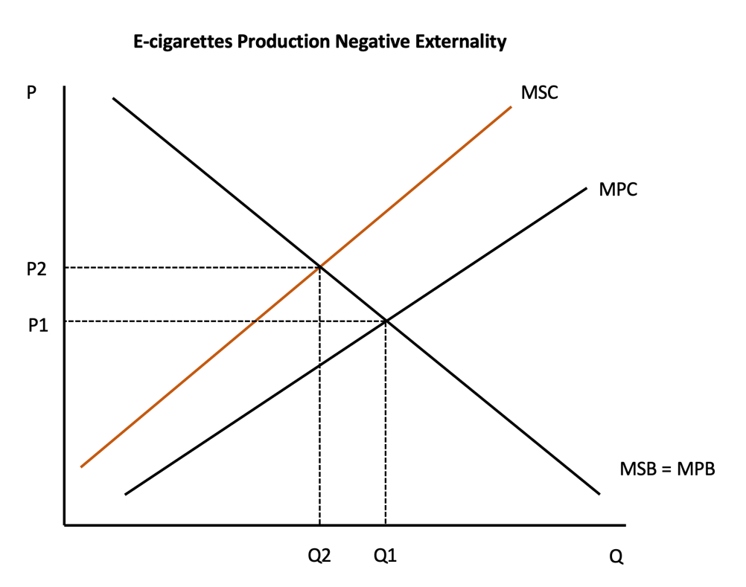

Suppose that production of e-cigarettes has spillover costs to society, mainly because of kids and teenagers consuming them. These costs are not incurred by the production firm, which implies that they are neither factored in the unit selling price nor the private marginal cost (MPC).
A profit-maximizing firm would produce up to the level marginal cost of a good equals the marginal revenue. Thus the market equilibrium output is Q₁ at price P₁. Selling at P_{1,} the firm meets the production costs and the profit margin sufficient to continue producing but at the cost of vaping among the minors, contrary to the US Food and Drug Administration (August 2016) Act. This Federal act banned the sale of e-cigarettes to minors within the United States.

When the Fed imposes an indirect tax on cigarettes, the firm cannot sell as much as Q₁ units. From the law of supply and demand in a simple production model, the prices increase in a falling quantity demanded. Inventories are rising so that the firm scales down the production to Q₂.
The firm's marginal supply cost curve constitutes the Private marginal cost plus the External cost, and the tax increase is equivalent to P₁-P₂.

At the output Q₂-Q₁, the firm cannot produce since they are not optimum as both marginal value and marginal costs are increasing. This output difference is neither transferred to the producer nor the consumer. Welfare loss is commonly referred to as dead weight or efficiency loss.

Elimination of the external costs brings the market for e-cigarettes at equilibrium, producing an efficient level of output Q₂ at an efficient price P₂. At this point, the negative externality is neutralized.
Any attempt to produce beyond this efficient point would result in a higher increase in prices and a decrease in quantity demanded. A production firm would maximize returns where MSC= MSB= Price (P₂).

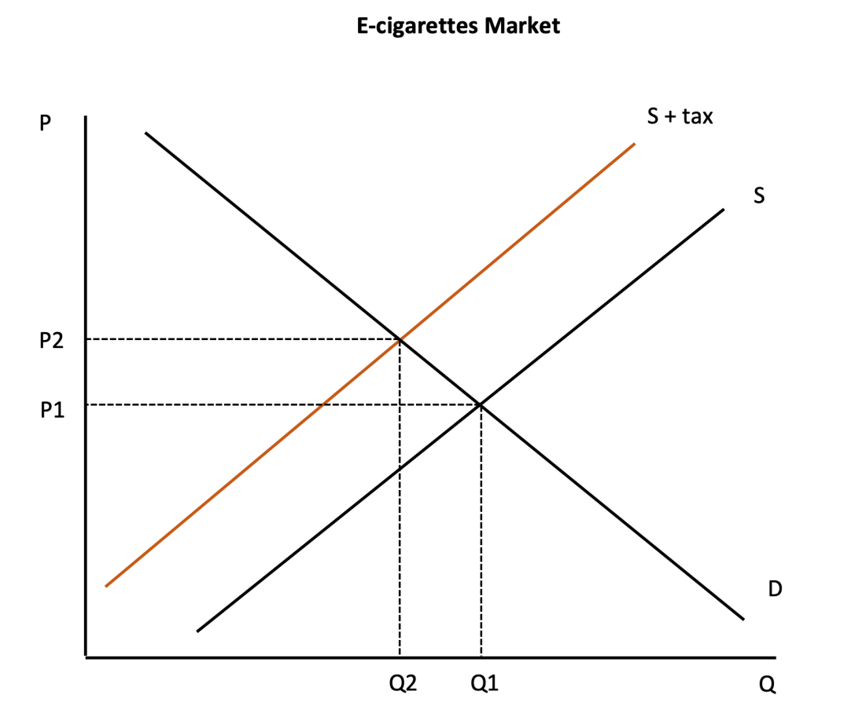

The government may use indirect taxes to control and regulate production activities within states. An indirect tax is purely attached to the unit price and can be varied by the government to suit prevailing economic conditions. For instance, to discourage harmful product consumption in the states, the state government may impose an indirect tax or increase where it exists. While the tax effects can be shifted back and forth to the manufacturers and consumers, respectively, the ideal function of deterring consumption of e-cigarettes by kids and teenagers would be achieved through higher unit price.

Suppose that the original demand curve, DD shows the marginal benefit of consuming e-cigarettes. Any point along this demand curve shows the quantity demand at a given level of price so that at the higher price, consumers will demand less.

Suppose further that the supply curve SS indicates the locus at which the producing firm is willing to supply to the market. This private marginal cost curve is upward sloping so that producers are more willing to produce at a higher market price.

The market equilibrium occurs when at price level P₁and output level Q₁. This level of output is referred to as the equilibrium output, which is not optimal.

The imposition of a 30% indirect tax to cover the external cost relating to the production and consumption of e-cigarettes by teenagers would increase the production cost to ( S+ tax ) curve. At this level, the firm could cut down the production to Q_{2,} and the unit prices would increase to P₂.

The fall in the quantity of output Q₁ to Q₂ represents the indirect tax on consumption and the resulting welfare loss in the market. The government uses the tax revenue to spur economic growth in other productive and healthy sectors. This tax leads to some level of income distribution and discourages unhealthy consumption. The efficient level of output in the economy is Q₂ at price P₂. At this point, the government eliminates market failures and costs that firms ignore.

The above analysis is deeply grounded on the basic assumption that e-cigarettes have an elastic demand curve. An increase in price due to indirect tax will cause more than a proportional decline in the quantity demanded. For e-cigarettes, a demerit good, this is not always the case for goods that tend to have an inelastic demand.

Suppose the demand for e-cigarettes is inelastic. In that case, it implies that the imposition of indirect tax would only earn the government revenue but will not discourage good consumption. The policy would be rendered ineffective and thus fail to achieve the desired effects.

In conclusion, tax choice to be adopted by the state or the Fed should be both efficient and effective to be varied accordingly to meet economic requirements. An indirect tax will not reduce the consumption level of e-cigarettes if it has an inelastic demand.

